Chapter I
Background of the Study
Education is essential for academic and professional growth, yet many students struggle due to limited tutoring access, financial constraints, and a lack of structured peer support. Traditional tutoring services are costly and inaccessible to many learners, leading to difficulties in understanding complex subjects. Digital learning platforms offer alternatives such as online tutoring and peer-assisted learning, but existing platforms often lack structured engagement, scalability, and affordability (Glomo-Narzoles & Glomo-Palermo, 2020; Topping, 2005).
This study introduces Tutorlink, a structured peer tutoring platform designed to enhance accessibility and affordability. Guided by peer-assisted learning (PAL) theory, it connects students with peer tutors, facilitates session scheduling, and incorporates feedback mechanisms to improve learning outcomes. By focusing on tutor-tutee matching and user engagement, Tutorlink provides a cost-effective and scalable alternative to professional tutoring services while maintaining simplicity and accessibility.
Tutorlink has significant real-world applications, particularly in education, where schools and universities can integrate it to supplement traditional learning. Organizations and communities can also use it to promote inclusive education. Challenges such as tutor quality and user engagement can be addressed through verification and feedback systems. Research supports structured peer tutoring as an effective learning method, improving both academic performance and accessibility (Glomo-Narzoles & Glomo-Palermo, 2020; Topping, 2005). Tutorlink aims to bridge gaps in existing solutions, ensuring a more inclusive and effective approach to academic support.
Objectives of the Study
To develop Tutorlink, a web-based peer tutoring platform that enables students to access affordable academic support, efficiently matches tutors and tutees based on expertise and availability, facilitates flexible session scheduling, and provides a structured feedback system.
- To determine the process involved in peer tutoring.
- To design and implement a web-based application in order to improve the process in peer tutoring.
- To determine the application’s level of usability and acceptability.
- To design an implementation plan of a proposed website.
By addressing these objectives, this study aims to develop Tutorlink as an innovative and structured peer tutoring platform that enhances learning accessibility, fosters collaboration, and improves academic outcomes in digital education.
Theoretical Background
The development of Tutorlink: Bridging Learners Through Peer Tutoring Platform is grounded in several educational and technological theories that emphasize collaborative learning, social interaction, and user-centered design. The platform incorporates foundational concepts from Peer-Assisted Learning (PAL), Constructivist Learning Theory with the Zone of Proximal Development (ZPD), the Technology Acceptance Model (TAM), Self-Determination Theory (SDT), and Social Learning Theory. These theories collectively support the platform’s aim to foster meaningful, self-directed, and socially engaging learning experiences.
Central to this study is the Peer-Assisted Learning (PAL) Theory, which provides the foundation for the platform's core functionality. PAL refers to an educational approach in which learners help one another to understand content, typically in structured tutoring sessions where one student assumes the role of tutor while the other is the tutee. This theory posits that both parties benefit from the interaction—tutors reinforce their understanding through teaching, while tutees receive more personalized and relatable explanations. PAL also promotes the concepts of cognitive congruence and social congruence. Cognitive congruence occurs when peer tutors explain concepts at an appropriate level of difficulty, making it easier for tutees to grasp. Social congruence, on the other hand, fosters a supportive and relaxed environment where learners feel comfortable asking questions and making mistakes. These elements are essential in Tutorlink’s design, as the system encourages pairing of students who are close in age or academic level to promote more effective communication and understanding.
Further, PAL has been widely recognized as a powerful method to enhance learning outcomes. Topping and Ehly (1998) emphasize that students often feel more at ease asking questions of peers than of instructors, leading to more interactive and meaningful learning experiences. By implementing PAL as a guiding theory, Tutorlink addresses both the academic and social needs of learners.
Tutorlink’s pedagogical framework is also grounded in Constructivist Learning Theory, which suggests that learners construct knowledge actively through experience and interaction rather than simply absorbing information. The theory emphasizes learning as a dynamic process influenced by social interaction, context, and prior knowledge. One of the key aspects of constructivism, particularly in Vygotsky’s interpretation, is the Zone of Proximal Development (ZPD). ZPD refers to the range of tasks that a learner can perform with the help of a more knowledgeable individual but cannot yet accomplish independently. In Tutorlink, the peer tutor assumes the role of the more knowledgeable other, helping the tutee move through their ZPD via guided practice, explanation, and encouragement.
The platform facilitates this process by enabling structured interactions, such as scheduling sessions, exchanging academic materials, and engaging in real-time discussions. This creates a digital learning environment where students learn not only through direct instruction but also through collaboration and shared problem-solving, which are essential elements of constructivism. Moreover, Tutorlink incorporates scaffolding—another core principle of constructivist learning—by offering support that gradually fades as learners gain independence. Through feedback systems, tutor ratings, and optional assistance tools, the platform provides the necessary guidance while encouraging learners to become self-sufficient over time.
In designing Tutorlink, the Technology Acceptance Model (TAM) plays a critical role in shaping the system’s interface and usability. TAM suggests that two main factors—perceived usefulness and perceived ease of use—significantly influence whether individuals adopt a new technology (Davis, 1989). To meet these criteria, Tutorlink is designed with an intuitive user interface that minimizes navigation effort while offering essential features, such as tutor matching, chat functionalities, and progress tracking. The perceived usefulness is reinforced by the platform’s ability to facilitate academic improvement, promote time-efficient study habits, and offer flexible scheduling—all of which are critical concerns for students. Furthermore, Tutorlink’s developers consider user feedback to continuously enhance the platform’s functionality. This iterative development process aligns with TAM’s implications, as improving perceived ease of use and usefulness through real-world testing increases user acceptance and sustained engagement.
The extended versions of TAM, such as TAM2, also highlight the importance of subjective norms and user experience. Tutorlink addresses these by incorporating peer reviews, testimonials, and ratings, which contribute to building trust and encouraging new users to participate. This approach enhances the social validity of the system and supports the theoretical framework for its adoption.
Self-Determination Theory (SDT), proposed by Deci and Ryan, provides insights into learner motivation and engagement. SDT asserts that individuals are more intrinsically motivated when their psychological needs for autonomy, competence, and relatedness are satisfied. Tutorlink addresses autonomy by allowing users to choose their preferred subjects, schedule sessions at their convenience, and select peer tutors they feel comfortable with. This freedom gives users control over their learning journey and encourages active participation. Competence is developed through measurable academic improvement, ongoing feedback, and achievements such as successfully tutoring others. Tutorlink also provides visual indicators of progress and improvement, reinforcing a sense of capability and accomplishment. Relatedness is nurtured through the platform’s social structure—interactive chat features, user profiles, and peer discussions foster a sense of community and mutual support.
Additionally, Tutorlink avoids relying solely on extrinsic motivators like badges or rewards. Instead, it emphasizes meaningful learning experiences and supportive peer relationships to build intrinsic motivation. By applying SDT, the platform is designed not just to help students learn but to help them want to learn.
The Social Learning Theory, developed by Albert Bandura, emphasizes that individuals learn through observing others, imitating behavior, and modeling. Learning is seen as a social process where behavior, environment, and personal factors all interact. In Tutorlink, this theory comes into play in multiple ways. Students observe their tutors’ study habits, problem-solving techniques, and communication strategies, which they may then adopt in their own academic routines. Observational learning is further supported by collaborative tools such as screen sharing, real-time discussion threads, and shared academic materials.
Bandura’s idea of self-efficacy—belief in one’s own ability to succeed—is also relevant. When students see peers like themselves successfully learning or teaching, it enhances their own confidence and willingness to engage. Tutorlink’s design leverages this by featuring peer success stories and allowing users to follow or communicate with highly rated tutors. Social reinforcement, such as praise and constructive feedback from peers, also helps reinforce desirable learning behaviors. Thus, Bandura’s theory supports Tutorlink’s emphasis on positive peer interactions, role modeling, and continuous improvement through shared learning experiences.
In conclusion, the theoretical foundation of Tutorlink is deeply rooted in well-established educational and psychological frameworks. Each theory—PAL, Constructivism with ZPD, TAM, SDT, and Social Learning—contributes uniquely to the platform’s design and functionality. Together, they guide the development of a digital space where students can actively participate in peer tutoring, gain academic support, and enhance their motivation and engagement in learning. By expanding on the application of these theories and ensuring their alignment with Tutorlink’s features, this theoretical background meets the requirement to provide a more comprehensive and in-depth discussion for academic review. It demonstrates how grounded theoretical principles can inform and enhance practical educational technology solutions.
Significance of the Study
This study aims to develop Tutorlink, a peer tutoring platform designed to enhance accessibility, affordability, and engagement in academic support. The research is significant as it contributes to the advancement of educational technology, providing an innovative and structured solution for students seeking academic assistance. By integrating peer-assisted learning (PAL) theory, Tutorlink improves tutor-tutee matching, scheduling, and feedback mechanisms, addressing the limitations of existing platforms. Tutorlink impacts the education sector by promoting collaborative learning and digital peer tutoring while fostering personalized and flexible learning environments. Schools and universities can incorporate the platform to supplement traditional teaching methods, improving students' academic performance and independence.
Tutorlink benefits various stakeholders. Students gain a cost-effective and structured tutoring system that connects them with peer tutors for targeted academic support. Tutors can earn income while sharing their expertise, developing their teaching skills, and reinforcing their knowledge. Educational institutions can integrate Tutorlink as a supplementary learning tool, enhancing student engagement and academic outcomes. Parents and guardians benefit from a verified and affordable academic support system as a reliable alternative to costly private tutoring. Additionally, software developers and IT professionals can use the study as a reference for future research in educational technology, particularly in intelligent tutor-matching algorithms and user-friendly scheduling mechanisms.
This research contributes to the understanding of peer-assisted learning in digital platforms, adding to existing studies on mobile-based tutoring solutions. It provides valuable insights into technology-driven learning strategies and their role in improving student engagement and academic achievement. The study also presents future opportunities, such as integrating artificial intelligence (AI) for adaptive learning, expanding subject coverage, and implementing real-time performance tracking. Future researchers can build on Tutorlink’s framework to explore advancements in education technology, user experience design, and learning analytics. By addressing these challenges, Tutorlink fosters an inclusive, accessible, and effective academic support system, making quality education more attainable for students in need.
Scope and Limitation of the Study
This study focuses on the development and implementation of Tutorlink: Bridging Learners Through Peer Tutoring Platform, a digital solution designed to enhance accessibility, affordability, and engagement in academic support. The platform integrates intelligent tutor-matching, flexible session scheduling, and a feedback mechanism to improve peer tutoring experiences. It aims to address the challenges of limited access to tutors, inefficient scheduling, and the lack of structured evaluation systems in existing tutoring platforms. Tutorlink will be developed as a web-based and mobile-friendly application, ensuring ease of access for students and tutors. The primary users of the system include students seeking academic assistance and peer tutors offering their expertise. The study will assess the platform’s effectiveness based on user engagement, satisfaction, and improvements in academic performance among tutees.
However, the study has several limitations. The platform will initially support only selected academic subjects, restricting its applicability to specialized fields. It will also be limited to a specific academic community, affecting its scalability beyond the study’s target users. Additionally, while the system offers intelligent tutor-matching, it relies on user-provided information, which may not always reflect real-time availability or expertise levels. The evaluation of Tutorlink’s impact will depend on the participation and feedback of users, which could influence the accuracy of the findings. Moreover, due to time constraints, the study will focus on the initial development, implementation, and short-term assessment of the platform, leaving room for further refinements and enhancements in future research. Despite these limitations, the study provides a foundation for improving digital peer tutoring platforms and contributes to the growing body of research on technology-driven educational solutions.
Chapter II
Review of Related Literature
Peer-assisted learning (PAL) is an effective educational approach where students help each other in the learning process. In a study by Chan et al. (2016), the roles and perceptions of peer tutors and tutees were explored at UCSI University. The findings highlighted that informal learning sessions, characterized by low power distance between tutors and tutees, enhanced learning outcomes. Tutors and tutees reported positive experiences, with increased academic performance and strengthened social relationships. The study emphasized the importance of clear roles and expectations in designing successful peer tutoring programs. Overall, the results suggest that PAL can effectively improve student engagement, performance, and satisfaction in higher education.
Moreover, a quasi-experimental study by Li et al. (2018) explored the impact of a peer tutoring program on the academic success of first-year nursing students. The study compared course failure rates and exam scores between students with and without access to peer tutoring. Results showed that students in the peer tutoring group had a significantly lower course failure rate (3.47%) compared to the non-tutored group (7.02%). Attendees of tutoring sessions saw an improvement of 4-5 points in their final exam scores. The study concluded that peer tutoring effectively reduced course failure rates and improved exam performance. Thus, peer tutoring provides a cost-effective way to support nursing students in overcoming academic challenges.
On the other hand, ESL peer tutors in Malaysia faced challenges in communication, time management, and group dynamics (Chai & Lin, 2013). Tutors struggled with language barriers, disruptive tutees, and sustaining engagement in simulation tasks. Specifically, 60% of tutors reported difficulties explaining concepts due to vocabulary gaps, while 40% cited time constraints in completing collaborative activities. Limited content knowledge and cultural passivity further hindered effectiveness. The study noted tutors spent 30% of session time managing off-task behaviors rather than facilitating learning. Nevertheless, despite these issues, peer tutoring fostered collaboration, though structured training and task redesign were recommended to address tutor preparedness and tutee participation. The study emphasized the need for institutional support to optimize PAL in ESL contexts.
Furthermore, Wolfe’s (2018) study on peer tutoring in a secondary computer science course demonstrated significant academic gains, with tutees improving post-test scores by 22% on average. The model paired high-achieving tutors (scoring ≥85% on pre-tests) with 5-6 tutees for a 7-week Google Drive unit. Quantitative data revealed ESOL and special education students showed the highest improvement (28%), narrowing achievement gaps. Qualitative findings highlighted enhanced collaboration, with 82% of tutors reporting improved leadership skills. Challenges included initial resistance from advanced students, but structured training (e.g., communication strategies) mitigated this. The study emphasized peer tutoring’s dual benefit: academic growth for tutees and soft skill development for tutors. Institutional support (e.g., teacher-designed materials) was critical for success.
Similarly, tutorial classes were highly effective in improving English proficiency, with students rating them positively for enhancing listening, speaking, reading, and writing skills (Glomo-Narzoles et al., 2020). Male and working students showed significant improvement, benefiting from personalized one-on-one sessions. Participants praised tutors for adapting content to their needs and fostering a supportive learning environment. Key strengths included tailored exam preparation and increased student confidence. Students reported high satisfaction with tutorial venues and scheduling flexibility. While most participants saw no need for changes, some recommended adding peer tutoring and digital learning materials. The study underscores tutorials as a vital tool for ESL learners, particularly in addressing language barriers and boosting academic performance.
In addition, Topping's (2005) review of peer learning trends highlights its evolution from simple tutoring to diverse applications like cooperative learning and peer assessment. The study emphasizes cognitive and socio-emotional benefits for both helpers and learners, particularly when roles are reciprocal. Key findings show peer learning improves academic performance, communication skills, and self-esteem when implemented with structured training and clear objectives. The author presents an integrated theoretical model linking organizational, cognitive, and affective processes in peer interactions. Recent extensions include applications in challenging subjects (e.g., science, thinking skills) and with exceptional learners. Technology integration (e.g., online peer learning) has expanded accessibility. While cost-effective, success depends on implementation quality, with structured methods outperforming informal peer grouping. The study advocates for whole-school approaches to ensure sustainability.
Moreover, the peer-tutoring program significantly improved first-year university students' academic performance, with experimental groups showing higher GPAs and success rates compared to controls (Arco-Tirado et al., 2020). Structured weekly sessions led by trained senior students enhanced self-regulated learning strategies across disciplines. Effect sizes demonstrated practical significance despite conservative statistical corrections. The program's success was attributed to its rigorous matching protocol, extended duration, and focus on metacognitive skills rather than subject content. Notably, dropout rates showed no significant difference, suggesting the intervention primarily impacted academic achievement rather than retention. The study's randomized controlled design strengthens causal claims about peer-tutoring efficacy in higher education.
Additionally, online peer tutoring platforms enhance accessibility and flexibility, allowing learners to connect across geographical boundaries and time zones (Enwereji et al., 2024). These platforms foster collaborative learning through real-time interactions, multimedia tools, and asynchronous communication, catering to diverse learning styles. Benefits include increased student engagement, personalized support, and opportunities for peer feedback. However, limitations such as technological barriers, lack of face-to-face interaction, and varying tutor quality can impact effectiveness. Successful implementation relies on structured guidelines, training for tutors, and user-friendly interfaces. Studies highlight improved academic outcomes when platforms integrate interactive features like video calls and shared digital workspaces. Challenges like digital equity and motivation sustainability remain critical concerns. The hybrid model (combining online and in-person elements) is suggested to maximize benefits while mitigating limitations.
Likewise, structured peer tutoring programs enhance academic outcomes in university settings through regular mentoring sessions and trained tutors (Arco-Tirado et al., 2020). These initiatives improve student performance by providing personalized guidance while developing effective learning strategies. Challenges include maintaining tutor consistency and program resources, requiring structured training and supervision systems. Research demonstrates their effectiveness when implementing organized mentoring frameworks with progress monitoring (Arco-Tirado et al., 2020). The model combines systematic organization with adaptable support to address implementation barriers. Sustaining tutor participation remains crucial for long-term success. Such programs prove particularly beneficial for first-year students transitioning to higher education. Institutions must balance program structure with flexibility to maximize benefits. These findings highlight peer tutoring as a valuable support mechanism in academic settings.
Meanwhile, recent studies highlight persistent challenges in virtual peer learning platforms, particularly regarding user engagement and session participation. Research indicates many users hesitate to initiate interactions in digital environments, while a significant portion of scheduled sessions fail to achieve full attendance (Chandra & Palvia, 2021). The SolveItNow platform successfully addressed these issues through AI-powered matching systems and gamification elements, substantially improving engagement metrics. Additional findings show that structured virtual icebreakers can effectively reduce participant dropout rates in online study groups (Lee et al., 2022). These technological solutions demonstrate how thoughtful platform design can enhance digital peer learning experiences. The studies collectively emphasize that overcoming participation barriers requires innovative user experience approaches. Such interventions prove particularly valuable for creating effective peer-to-peer learning environments in online education.
Extensive research has established the effectiveness of peer tutoring in improving academic performance, with studies showing significant test score improvements (Wolfe, 2018) and reduced course failure rates (Li et al., 2018). However, important gaps remain in our understanding of how to sustain these benefits over time, particularly in digital learning environments. Most existing studies focus on short-term outcomes within single semesters, while challenges persist in making programs scalable, affordable, and consistently engaging. Online peer tutoring, while promising, continues to face difficulties with maintaining personal connections, keeping students motivated, and accurately measuring learning progress.
This study addresses these challenges through the development of TutorLink: Bridging Learners Through Peer Tutoring Platform. Our solution combines the strengths of in-person and online tutoring through a flexible hybrid model. The platform features a comprehensive matching system that considers academic needs, learning styles, and language proficiency levels, along with scheduling tools and progress tracking. By incorporating both live and self-paced learning options, TutorLink maintains the personal interaction valued in traditional tutoring while achieving the accessibility and cost-effectiveness of digital platforms.
TutorLink's design specifically targets the current limitations in peer tutoring accessibility and sustainability. The platform makes quality academic support available to students who typically cannot afford private tutoring services, addressing the financial barriers that exclude many learners. With built-in tools for program evaluation and tutor training, TutorLink also helps institutions implement and maintain effective peer learning programs. This study responds to the growing need for tutoring solutions that combine academic effectiveness with practical scalability, particularly in our evolving educational landscape where both digital and in-person learning play important roles.
Conceptual Framework
This study employs a conceptual framework to develop the RJ Microfinance Lending Management System, addressing challenges and opportunities through a mixed-methods research approach. By integrating automation, digital payments, and multi-factor authentication, the system aims to modernize processes, reduce errors, and enhance transparency. Continuous feedback ensures adaptability, delivering an efficient and user-friendly loan management solution for borrowers and lenders.
OUTCOME
- Improved Tutor–Tutee Matching Efficiency
- Flexible & Organized Session Scheduling
- Enhanced Learning Engagement and Performance
- High Usability, Acceptability & User Satisfaction
OUTPUT

Tutorlink: Bridging Learners Through Peer Tutoring Platform
PROCESS
- System Design (UI/UX, database schema, architecture)User Requirements (students, tutors, faculty)
- Development using Iterative SDLC Technology Stack (ReactJS, Tailwind, Node.js, MySQL)
- Tutor–Tutee Matching based on expertise/
availability
- Real-time Scheduling & Communication
- Feedback, Rating & Performance Review
INPUT
- Peer-Assisted Learning (PAL) Theory
- User Requirements (students, tutors, faculty)
- Tutor/Tutee Profiles & Subject Needs
- Technology Stack (ReactJS, Tailwind, Node.js, MySQL)
- Scheduling & Availability Data
- Feedback & Evaluation Criteria

Figure 1.0 Conceptual Framework
Figure 1.0 presents the conceptual framework, showing the relationship between the theories, legal guidelines, and technologies used in developing the lending system. It provides a clear flow of how the system is planned, designed, and improved. It also highlights how each stage contributes to building a more organized, reliable, and user-friendly platform, ensuring that the system functions smoothly and meets the needs of administrators, tutors and tutees.
Related Studies
The Elearning System Online Platform as described in iNetTutor.com (2022), serves as a centralized platform for students, instructors, courses, and the class as a whole. It is a digital platform that facilitates learning. Elearning platform will provide students with an enjoyable process of learning using the zone where they find learning accessible, resourceful and amusing. Elearning System Online Platform is designed as another innovative way of learning. Students will benefit from a well-designed, learner-centered, and interactive learning environment as a result of this project. Specified courses are introduced on a digital platform that may be accessed by anyone, at any time and from any location.
Similarly, the iPASS Project: An Online Tutoring System is described by Mark Rabinovich as an innovative online tutoring system for remedial writing students that has been in use at Queensborough Community College since 2006. The design of iPass was based on constructivist learning theories that conceptualize learning as a transactional and dynamic process that can occur anywhere at any time. This e-tutoring system helps students develop their writing skills by means of a suite of collaborative Web applications that asynchronously link students to e-tutors and allow students to use different learning methods. The success of the system has been demonstrated by a significant increase in participating students' scores on standardized examinations as well as in an increased pass rate in writing-centered courses.
In relation to this, the study Online Learning Management System with Android & IOS APP is a marketplace script for online learning. Here students and teachers are combined together for sharing knowledge through a structured course-based system. Teachers or instructors can create an unlimited number of courses, video lessons and documents according to their expertise and students can enroll in these courses and make themselves skilled anytime and from anywhere. (Yugesh Verma,2021).
The E-Class Management System (iNetTutor.com 2021), is designed to effectively facilitate the e-learning processes of students. The system will allow the admin to manage all aspects in an e-class, from students, instructors, courses, and other e-class related information. The system will allow easy, fast, efficient, and accurate e-class management. Efficient management of e-classes will provide students with an enjoyable process of learning using the zone where they find learning accessible, resourceful, and amusing.
The Online Peer-Tutoring for Programming Languages Based on Programming Ability and Teaching Skill is an online peer-tutoring platform for programming languages with peer mentoring is established herein for one-to-one peer tutoring activities. With students with higher learning ability as tutors and those with lower learning ability as tutees, tutors can provide online peer tutoring for programming languages via demonstrations and flowcharts to discuss the effects of using different teaching methods for learning activities on the learning achievement of tutees (Kuo, et.al 2022).
The Online Private Tutor Finder System by Heng Jie You (2023) is an online private tutor finder system for academic purposes. The application supports three party which are students, parents, and tutors. Tutors can perform files upload, scheduling, activities creation, view student performance, and create new subjects for listing. While for parents, they are able to manage their children and courses. They can also view rating for choice analysis purposes when selecting the suitable tutors for the children. In addition, students account who are created by parent account, able to view subject information enrolled by parents. They can access the learning materials uploaded by tutors, they can view and download the files into a zip, they can also view the activities uploaded by tutors. If the student has uncompleted activities, then they can proceed with completing the question and get the computed mark instantly after refreshing the page. The student can also view the previous result of the completed activities.
The study Development of an Intelligent Tutoring System for English Reading Comprehension: Design Based on Philippine Public School Flexible Learning Experience presents an intelligent tutoring system as seen to be successful in assisting in the instruction of basic skill, particularly, reading comprehension The system adapted considerable instructional needs of learners from early development to advanced reading comprehension skills. The developed system provided an immediate feedback to learners upon completion of an activity without requiring intervention from a teacher(Marinas et.al 2021).
Similarly, MentorWayz: An Android Tutor Finder Application for Junior and Senior High School Students, is an application enables users to search and book for registered tutors on the application and provide recommendation to the users. The application contains personal details of registered tutors and their respective location. Pictures and contact information of registered mentors are also provided (Pagkaliwagan et.al,2022).
The Live-eTutor is an online tutoring program ran by qualified live tutor’s online perfect or your children to enhance their education online. Online tutoring is an easy way to teach kids and to let them have fun while learning. Live-eTutor has advanced online tutoring techniques using an advanced online classroom to tutor children online. By using an online tutoring white board, both kids and tutors can write down their thoughts and communicate effectively over the internet.
The capstone project of the researcher focused on developing an online service marketplace mobile application called FindATutor. It is an application that connects Filipino students to Filipino teachers around the country. The application allows students to save time in finding a tutor that can help them improve their academic performance and their intrinsic motivation to study.
CHAPTER III
Research Methodology
This chapter presents the research design and methodology adopted in the study. It discusses the approaches used to gather, evaluate, and interpret data in addressing the research questions. The chapter further explains the research design, sampling techniques, data collection instruments, and data analysis procedures applied to ensure the reliability, validity, and overall credibility of the findings.
Research Design
This study will utilize a Design and Development Research (DDR) methodology to develop Tutorlink: Bridging Learners Through Peer Tutoring Platform. The DDR approach will be appropriate for this study as it involves the systematic design, development, and evaluation of a functional technological solution (a peer tutoring platform) that aims to address academic challenges such as limited access to tutoring services, financial constraints, and the lack of structured support for learners. Guided by the Peer-Assisted Learning (PAL) theory, the study will aim to provide a platform where students can sign up as tutors or tutees, schedule sessions, and give feedback after each session.
Systems Development Life Cycle (SDLC)
This study will adopt the Systems Development Life Cycle (SDLC) framework, specifically the Agile model, which promotes iterative and incremental development. Agile will be appropriate for Tutorlink as it allows flexibility, continuous feedback, and progressive improvements. The process will begin with planning, where the system’s objectives will be defined and feasibility assessed. User requirements will be gathered through interviews, surveys, and document analysis involving students and faculty, forming the product backlog. In the design phase, user interface wireframes, system architecture, and a database schema will be created. Development will be carried out in sprint cycles, incrementally building features such as registration, tutor-tutee matching, scheduling, and feedback. After each sprint, the system will undergo unit testing and integration testing to ensure that individual components function correctly and work together seamlessly. User acceptance testing (UAT) will also be conducted with selected users to validate that the system meets their needs and expectations. Deployment will involve launching a working version for pilot testing. Maintenance will continue through future sprints for updates and improvements based on user feedback.
Project Development

a.Gantt Chart
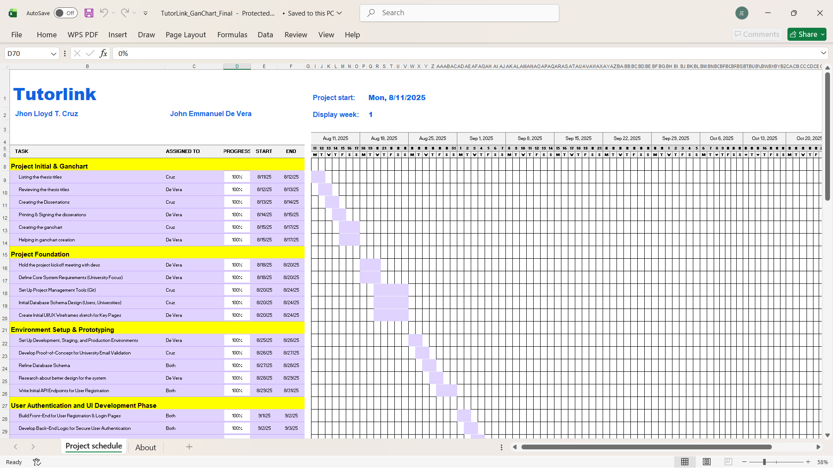
Figure 2.0 Gantt Chart for Software Development

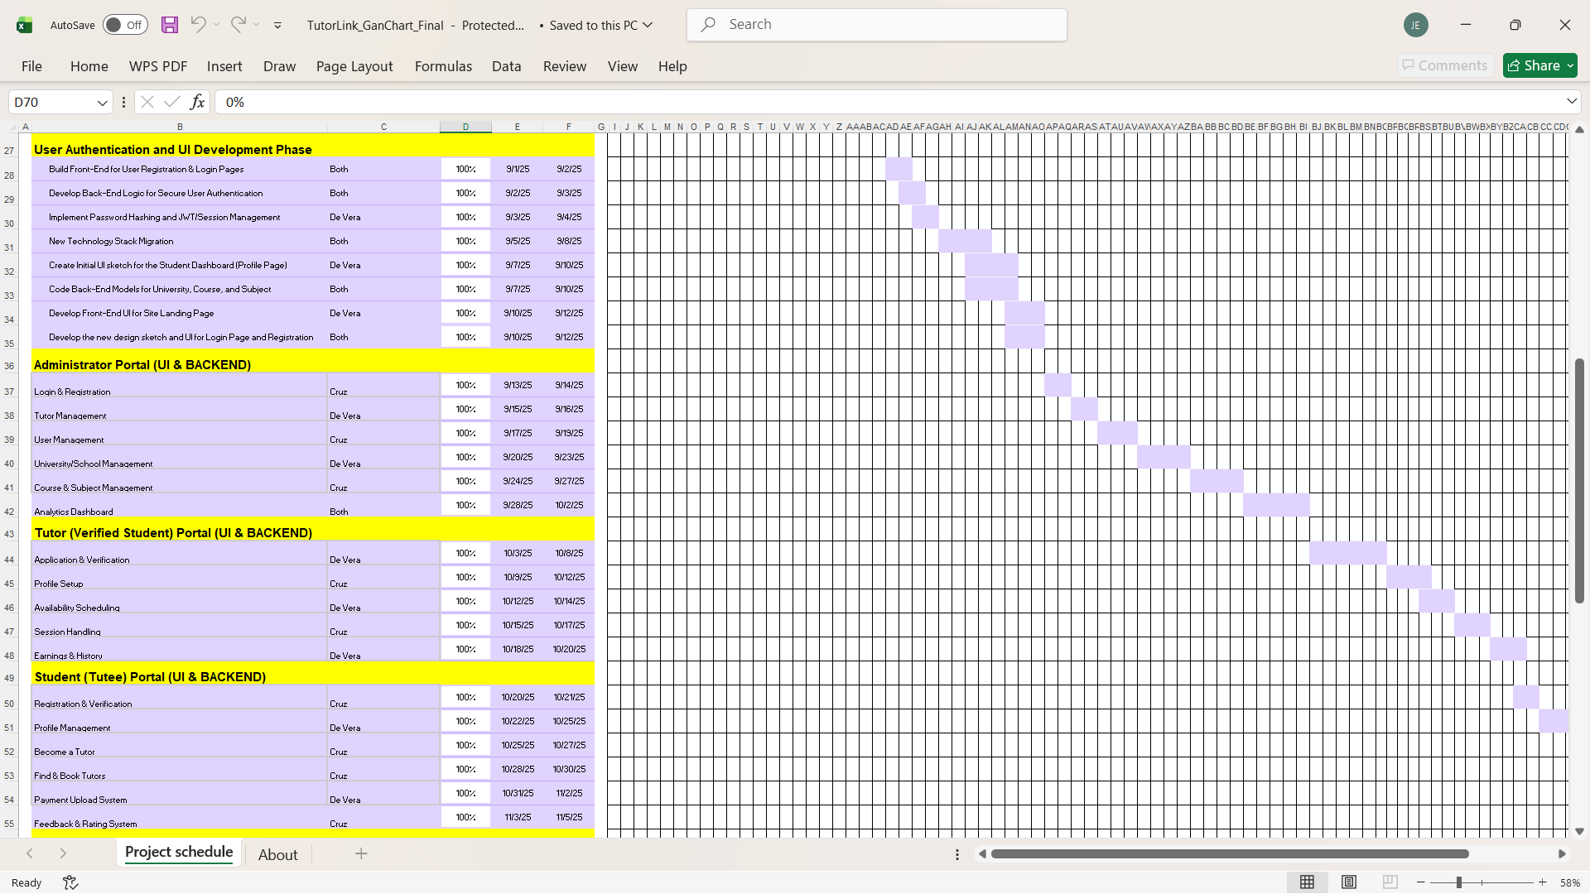
Figure 3.0 Gantt Chart for Software Development

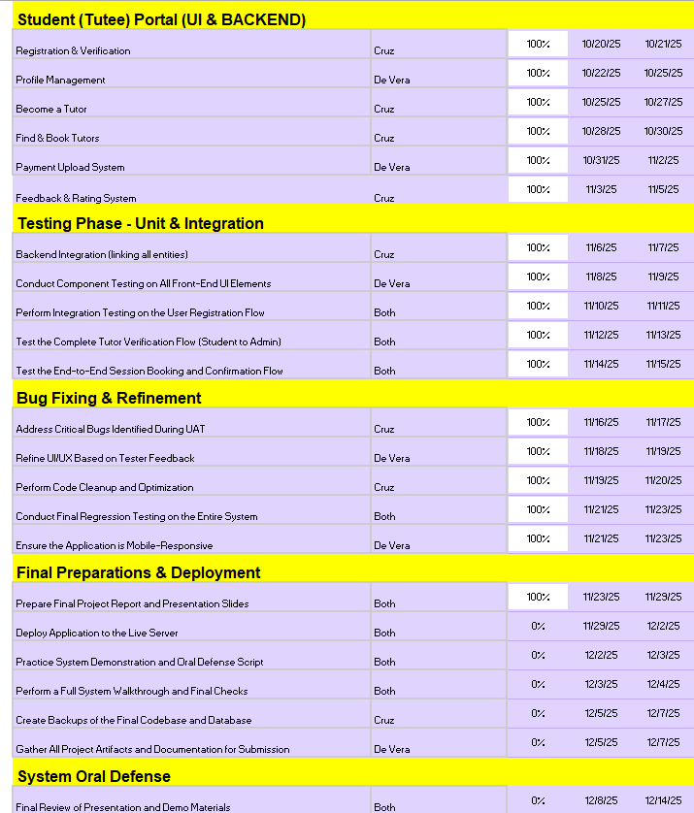
Figure 4.0 Gantt Chart for Testing and Documentation

b.Project Evaluation
This project focused on developing Tutorlink, a peer tutoring platform designed to improve how students access academic assistance and how tutors manage their sessions. The main goal of Tutorlink is to provide an organized, accessible, and affordable learning support system by digitizing the entire tutoring process. Before this platform was developed, peer tutoring activities were usually arranged through group chats, informal message threads, or manual scheduling—an approach that often led to confusion, missed sessions, and difficulty tracking tutor–tutee interactions. These challenges helped define the system’s core features and guided its overall development.The first step in creating Tutorlink was the development of an intuitive interface for both tutors and tutees. This interface allows users to browse available tutors, select subjects they need help with, and view tutor profiles that include experience, skills, and availability. The design was kept simple and clean to ensure it could be used easily by students across different academic levels.The next phase involved building the session scheduling feature, which enables users to book tutoring sessions based on real-time tutor availability. Once a tutee requests a schedule, the tutor can confirm or decline the booking, creating a more organized and transparent process. This step ensures that sessions are properly documented and eliminates misunderstandings about meeting times.Security and communication features were then integrated into the system. User credentials are protected through secure authentication methods, and a messaging feature was added to allow tutors and tutees to communicate efficiently. This built-in messaging tool ensures that instructions, clarifications, and updates happen within the platform, keeping all academic interactions neatly organized.
Finally, Tutorlink incorporated an admin interface that manages user accounts, verifies tutor profiles, and monitors platform activities. Administrators also have access to tools that allow them to oversee feedback reports and address issues related to user conduct or system usage.
By integrating these components, Tutorlink successfully addressed the recurring issues of disorganized communication, inconsistent scheduling, and lack of structured feedback in traditional peer tutoring setups.
Requirements Analysis
The development of Tutorlink was driven by the need to improve the accessibility and organization of peer tutoring services. Traditional setups often rely on informal communication channels, making it difficult to track schedules, confirm appointments, or ensure tutor availability. These limitations affect both tutors and tutees, resulting in missed sessions, unclear expectations, and inconsistent learning support. Tutorlink was designed to solve these problems by providing a centralized and structured system. The platform caters to two main user groups—tutors and tutees—each with specific needs. Tutees require a simple way to find qualified peer tutors, schedule sessions, and track their academic progress. Tutors need a platform where they can manage their availability, view session requests, and receive feedback from students they assist.
Administrators also play an important role in the system. They verify tutor information, manage user accounts, and ensure that the platform operates smoothly. By validating tutor identities and reviewing submitted requirements, administrators help maintain the credibility and safety of the platform. Tutorlink also enables tutees to submit reviews after each session. These reviews help tutors improve their performance and guide other students in choosing the best tutor for their needs. To support smooth academic transactions, the platform includes features for tracking schedules, monitoring booked sessions, and sending notifications for upcoming meetings. By clearly defining the roles and requirements of tutors, tutees, and administrators, Tutorlink provides a more reliable, transparent, and efficient peer tutoring experience.
System Architecture
Tutorlink was built using a modern technology stack to ensure speed, reliability, and ease of use. The system follows a client–server architecture where the frontend and backend work together to deliver a seamless user experience.
The frontend of the platform was developed using ReactJS, paired with TailwindCSS for fast and responsive styling. This combination allows the interface to remain clean, visually consistent, and accessible across different devices. Pages such as tutor profiles, schedules, session bookings, and dashboards were designed with simplicity in mind to help users navigate without difficulty. The backend is powered by Node.js, which handles essential operations such as login authentication, tutor–tutee matching, session scheduling, and feedback submission. Node.js enables fast processing of requests and supports real-time updates—important for features like availability checking and session notifications.
To store all user-related information, MySQL serves as the system’s relational database. It organizes tutor profiles, tutee accounts, schedules, session history, and feedback data in a structured format, ensuring that information is stored securely and can be retrieved efficiently when needed.
During the early stages of development, XAMPP was used as a local server environment to host the database and facilitate testing. This setup allowed the development team to quickly adjust features, test system responses, and troubleshoot inconsistencies before deployment.
By combining these tools, Tutorlink achieves fast performance, secure data handling, and a user-friendly interface—making it a practical solution for peer tutoring environments.
Design Specification
The creation of Tutorlink required several tools, equipment, and resources to ensure efficient development and proper documentation. The team selected these materials based on usability, availability, and their suitability for producing a stable and scalable system. ReactJS and TailwindCSS served as the primary tools for frontend design, enabling developers to create a dynamic and responsive interface. TailwindCSS provided utility-based styling that helped craft clean layouts while maintaining consistency throughout the platform. Visual Studio Code (VS Code) functioned as the Integrated Development Environment (IDE), offering essential features such as code editing, debugging, and extension support. Built-in Git integration allowed developers to work collaboratively through version control and maintain clean code across multiple modules.
To handle data management, MySQL—hosted initially through XAMPP—was used. MySQL efficiently stored user records, schedules, feedback logs, and session details while ensuring data integrity and organization.
The system’s backend was built using Node.js, which provided a JavaScript-based runtime for server-side operations. This choice streamlined development, allowing both frontend and backend components to use a unified programming language. Node.js also ensured fast response times and stable API communication between the client and the server.
For testing and deployment, web browsers such as Google Chrome were used to simulate real-user interactions, evaluate interface responsiveness, and detect bugs. Notifications and updates were also supported through backend services designed to enhance communication between tutors and tutees.
By integrating these tools, Tutorlink achieved a balanced combination of usability, functionality, and system stability, resulting in a platform that aligns with the needs of both academic users and system developers.

Database Schema
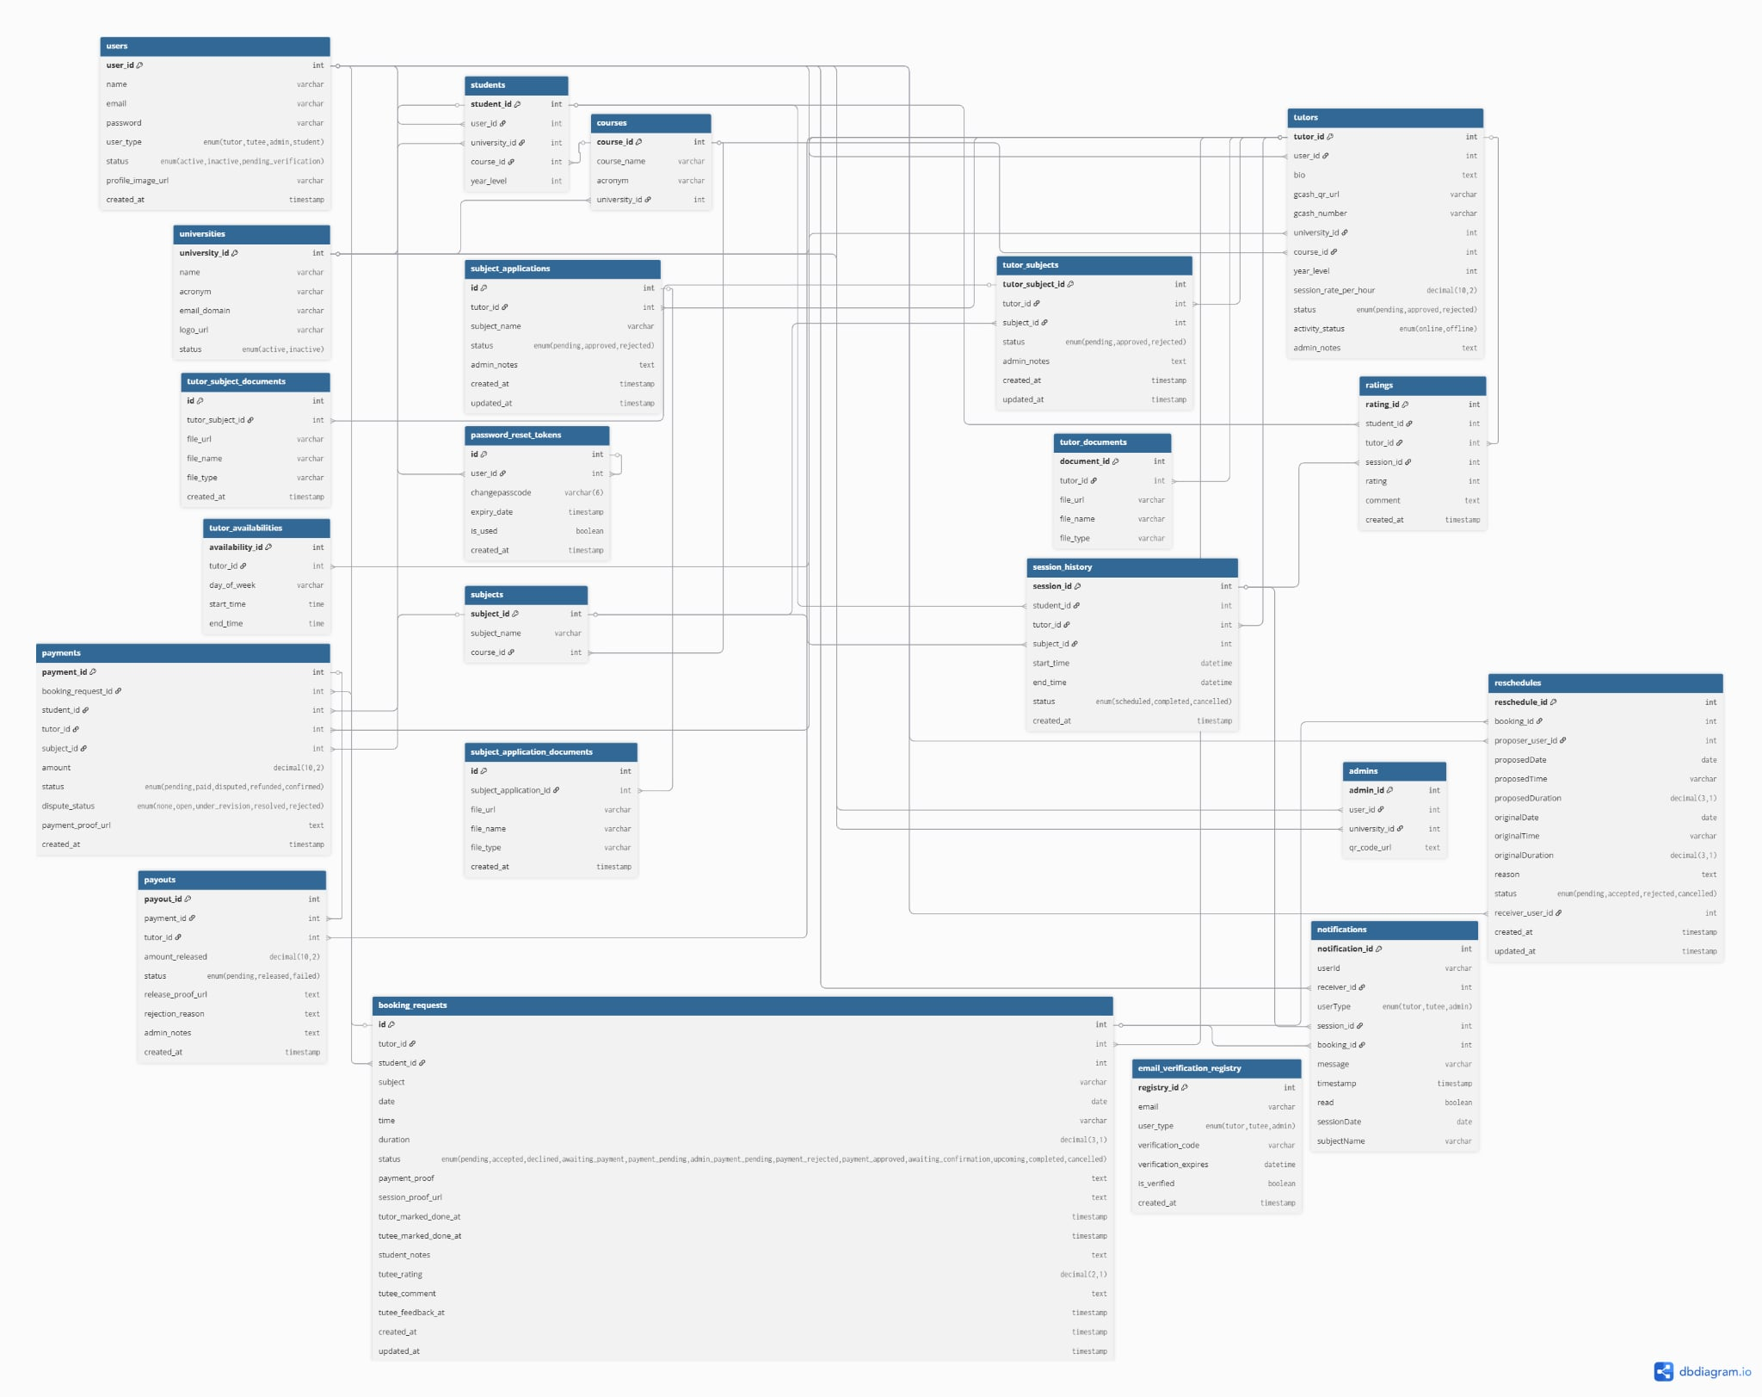
Figure 5.0 Database Schema

Research Instrument
To determine the existence of academic support gaps among students and assess the feasibility and acceptance of Tutorlink as a peer-to-peer tutoring platform, the researchers developed the Tutorlink: Peer Tutoring Demand & Solution Validation Survey. The instrument is composed of five sections: respondent profile, academic support problem verification, solution validation, adoption and feasibility, and problem–solution justification. Section one gathers demographic information such as age, gender, year level, and academic program. Section two evaluates the presence and severity of academic difficulties using both multiple-choice and 5-point Likert-scale items focusing on accessibility of academic help and its impact on performance. Section three measures perception of Tutorlink as a feasible solution, including trust in peer tutoring and system functionality, while section four assesses willingness to use the platform as a tutor or tutee, including comfort with digital payment methods like GCash. The final section captures user insights and narrative feedback to support system refinement. Data collected through this survey serves as a basis for validating the need for the platform and guiding improvements in system usability, features, and deployment for academic implementation.
Research Environment and Respondents
The study was conducted within the student population of Bohol Island State University – Calape Campus, where Tutorlink was introduced as a proposed peer tutoring platform. A Google Forms survey was distributed to students across various courses and year levels, allowing responses to be gathered efficiently and ensuring wide coverage within the institution. These students served as the primary respondents, as they are the intended users of the system—either as tutees seeking academic assistance or as tutors capable of mentoring peers. Their firsthand academic experiences and accessibility challenges made them ideal participants for validating the need for the platform and assessing the feasibility of peer tutoring as a structured digital solution.
Purposive sampling was applied to include students who expressed interest in joining the platform either as tutors or learners, while convenience sampling was used in disseminating the form to enrolled students who were available and willing to participate. Through this approach, the researchers obtained varied perspectives that reflected the real conditions and academic needs within the campus. The feedback gathered provided valuable insights into students' challenges in seeking academic help, their willingness to use a peer tutoring system, and their acceptance of Tutorlink as a potential support tool for improving accessibility and academic performance.
Data Gathering Procedure
The data for this study were collected through the Tutorlink: Peer Tutoring Demand & Solution Validation Survey, which was developed to assess the academic support needs of students and determine the feasibility, acceptability, and potential usability of the Tutorlink peer tutoring platform. The survey consisted of five major components: respondent profile, academic support problem verification, solution validation, adoption and feasibility, and problem–solution justification. These sections aimed to generate measurable data regarding students’ difficulties in accessing academic assistance, their willingness to use peer tutoring services, and their perceived value of Tutorlink as a digital learning support system.
The survey was administered online using Google Forms, and the link was distributed to students across various programs at Bohol Island State University – Calape Campus. Before answering, respondents were informed of the study’s purpose and were assured that participation was voluntary and that all responses would be treated with strict confidentiality. Instructions were provided within the form to guide respondents in completing both rating-scale and open-ended questions.
Data collection was carried out within a set duration to ensure that students from different year levels and courses had ample time to respond. The researchers monitored the ongoing submission of responses and remained available for clarification or assistance when needed. Upon completion of the data gathering period, responses were reviewed for completeness, organized, and encoded for analysis to support the system validation, usability interpretation, and refinement of Tutorlink.
Statistical Treatment
The data gathered from student respondents were analyzed using descriptive statistics to measure the perceived need, usability, and acceptance of the Tutorlink peer tutoring platform. The responses from the Google Forms survey were quantified through mean computation, allowing the researchers to determine the general perception of the participants regarding academic support accessibility and the feasibility of Tutorlink as a solution. Jamovi was used to process and interpret the data, generate tabulations, and present results through visual summaries for a clearer understanding of trends and user feedback.
The survey utilized a 5-point Likert scale to measure the degree of agreement or disagreement with system-related statements. The numerical values and their corresponding qualitative descriptions are as follows:

Scale | Range | Description | Interpretation
5 | 4.21 – 5.00 | Strongly Agree | Respondents fully support the concept and usability of Tutorlink.
4 | 3.41 – 4.20 | Agree | Respondents believe the platform is usable and beneficial.
3 | 2.61 – 3.40 | Neutral | Respondents are undecided or perceive average usability.
2 | 1.81 – 2.60 | Disagree | Respondents doubt the usability or necessity of the platform.
1 | 1.00 – 1.80 |  | Respondents do not believe the system is valuable or usable.
  Strongly Disagree

The defined mean range served as the interpretative basis for evaluating user perception. This categorization allowed the researchers to translate numerical results into meaningful qualitative insights regarding the relevance, acceptability, and feasibility of Tutorlink. Through this structured method of statistical treatment, the study identified areas where the platform performed strongly and aspects that may require further development or enhancement.
Definition of Terms
Admin – The controller of the system responsible for user approval, monitoring processes, and system maintenance.
Authentication – The login verification process that ensures secure user access to the platform.
Booking System – The module of Tutorlink that manages session requests, confirmations, and reserved time slots.
Dashboard – The main interface where tutors or tutees view available sessions, schedules, and recent activities.
Feedback and Rating – A post-session evaluation feature where tutees assess the tutor’s performance for quality monitoring.
Peer Tutoring – A system approach where students help other students understand academic lessons through guided study sessions.
Profile Verification – The review and approval process conducted by admin to confirm tutor identity and qualifications.
Secure Payment (GCash) – A digital transactional feature used for compensation between tutees and tutors.
Session Scheduling – A feature that allows tutees to book and arrange tutoring sessions based on tutor availability.
Tutor – A student user who offers academic assistance to peers and may earn through scheduled tutoring sessions.
Tutor–Tutee Matching – The system process of connecting students based on subject needs, availability, and tutor competence.
Tutorlink – A peer tutoring platform developed to connect students for academic support through organized scheduling, tutor matching, and feedback features.
Tutee – A student user seeking academic help by booking sessions with available peer tutors.
User Registration – The process in which students create an account to join Tutorlink either as a tutor or tutee.

References
1. Peer Assisted Learning in Higher Education: Roles, Perceptions and Efficacy
https://core.ac.uk/reader/148366770
2. Impacts of peer tutoring on academic performance of first-year baccalaureate nursing students: A quasi-experimental study
https://www.sciencedirect.com/science/article/abs/pii/S0260691720315082
3. Perceptions of ESL student tutors on challenges faced in
peer tutoring
https://www.researchgate.net/profile/Siew-Lin/publication/283297833_Perceptions_of_ESL_Student_Tutors_on_Challenges_Faced_in_Peer_Tutoring/links/58071fd508ae5ad188166b40/Perceptions-of-ESL-Student-Tutors-on-Challenges-Faced-in-Peer-Tutoring.pdf
4. The Impact of a Peer-tutoring Model on the Academic Performance of Secondary Students
https://www.proquest.com/openview/7264392b4963cd54da8d40ba325c8ed8/1?cbl=18750&pq-origsite=gscholar
5. Glomo-Narzoles, A. & Glomo-Palermo, J. (2020). Effectiveness of Tutorials in Improving the Academic Performance of English Language Learners. International Journal of Language and Literary Studies
https://mail.ijlls.org/index.php/ijlls/article/view/380/129?fbclid=IwZXh0bgNhZW0CMTEAAR3q7ibZiFlhJTvV3cY2I8CY_0dUnzb4miSsNe0N6BFBdizvfMCR2U3k4_aem_F4Aov63DIW9qsVXkRlVlqQ
6. Topping, K. J. (2005). Trends in Peer Learning. Educational Psychology, 25(6), 631-645.
https://scispace.com/pdf/trends-in-peer-learning-101zpr6v7g.pdf
7. Online Peer-Tutoring for Programming Languages Based on Programming Ability and Teaching Skill
https://www.mdpi.com/2076-3417/12/17/8513
8. Examining the Views of non-e-Tutoring Students on Potential Benefits and Drawbacks of Incorporating e-Tutoring into Their Learning Experience
https://books.google.com.ph/books?hl=en&lr=&id=RCI9EQAAQBAJ&oi=fnd&pg=PT87&dq=Online+Peer+Tutoring+Platforms:+Benefits+and+Limitations&ots=P5O3jfycBb&sig=0pVYz808AeGfncAu4hy0uPvvnRg&redir_esc=y#v=onepage&q=Online%20Peer%20Tutoring%20Platforms%3A%20Benefits%20and%20Limitations&f=false
9. Evidence-based peer-tutoring program to improve students’performance at the university
https://www.tandfonline.com/doi/epdf/10.1080/03075079.2019.1597038?needAccess=true
10. Online education next wave: peer to peer learning
https://www.tandfonline.com/doi/epdf/10.1080/15228053.2021.1980848?needAccess=true
11. iNetTutor.com. (2022, January 24). Elearning System Online Platform
https://www.inettutor.com/programming-tutorial/bootstrap/elearning-system-online-platform-free-bootstrap-template/#Abstract
12. Rabinovich, M. (2009). iPASS Project: An Online Tutoring System. Innovate: Journal of Online Education, 5(4),. Retrieved December 1, 2025 from https://www.learntechlib.org/p/104244/.
13. Verma, Yugesh (August 26, 2021 ). Online Learning Management System with Android & IOS APP Online Learning Management System with Android & IOS APP | Projectworlds
14. iNetTutor.com. (2021, August 16). E-Class Management System
E-Class Management System - Free Sample 2025
15. Kuo, Y.-C., Yao, C.-B., & Wu, Z.-Y. (2022). Online Peer-Tutoring for Programming Languages Based on Programming Ability and Teaching Skill. Applied Sciences, 12(17), 8513. Online Peer-Tutoring for Programming Languages Based on Programming Ability and Teaching Skill
16. You, Heng Jie (May,2023). Online Private Tutor Finder System Online Private Tutor Finder System - Final Year Project Report (BIS) - Studocu
17. Day Bert R. Mariñas, Roberto R. Coloma, Lin V. Tadeja, Shaira Marie J. Castillo, Katherine D. Tan, Frederick F. Patacsil, "Development of an Intelligent Tutoring System for English Reading Comprehension: Design Based on Philippine Public School Flexible Learning Experience", International Journal of Information Engineering and Electronic Business(IJIEEB), Vol.13, No.5, pp. 9-23, 2021.
https://www.mecs-press.org/ijieeb/ijieeb-v13-n5/IJIEEB-V13-N5-2.pdf
18. Pagkaliwagan, Joshua B., Portugal, Wenros M., Tobeo, Elbert V., Mentorwayz:An Android Tutor Finder Application for Junior and Senior High School Students.
MentorWayz An Android Tutor Finder Application For Junior and Senior Highschool Students | PDF | Android (Operating System) | Educational Technology
19. Scribd.com(2019) Live-eTutor E-Tutoring Guide for Educators | PDF | Educational Technology | Tutor
20. Studocu.com (2023). Proposal Sample #1 - Capstone Project on Online Tutoring App Development. FindATutor. Proposal Sample #1 - Capstone Project on Online Tutoring App Development - Studocu

